PROMISE & PRACTICE · DEEP DIVE · SOURCE ANALYSIS
The Caning of Sumner — House & Divided
One Caning, Two Americas
Name: ______________________________ Period: _____ Date: ________________
WHAT I CAN DO TODAY I can read primary sources about The Caning of Sumner — House & Divided, weigh who made each one and why, and use evidence to answer historical questions.
Directions. Historians know that where you stand changes what you see. Read how each side described the exact same event, then explain the gap

THE SOURCES
THE IMAGE · THE NORTHERN VIEW · 1856 — “Southern Chivalry — Argument versus Club's”
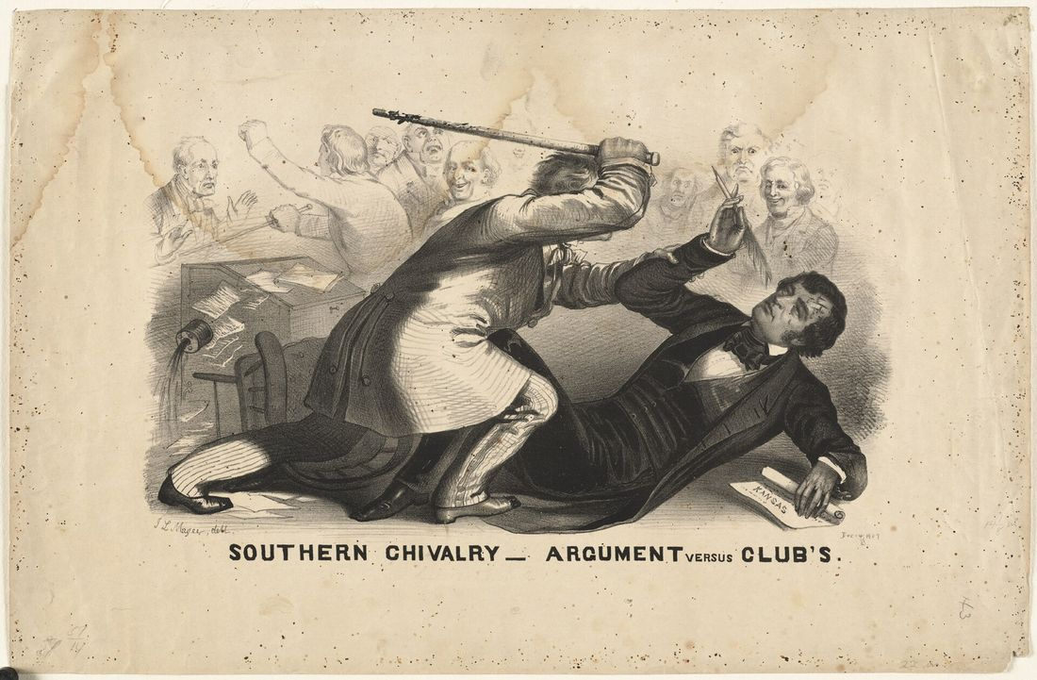
Look closely: Brooks stands over a defenseless Sumner, who holds only a pen and a paper marked “Kansas.” The title calls it “chivalry” — the Southern ideal of the honorable gentleman
“Southern Chivalry — Argument versus Club's” — lithograph by John L. Magee, 1856, public domain (Library of Congress).
SOURCE A · A NORTHERN NEWSPAPER · 1856 — The New-York Evening Post
“Has it come to this, that we must speak with bated breath in the presence of our Southern masters? … Are we too, slaves, slaves for life, a target for their brutal blows, when we do not comport ourselves to please them?”
— New-York Evening Post, May 1856. Public domain
— New-York Evening Post, May 1856. Public domain.
SOURCE B · A SOUTHERN NEWSPAPER · 1856 — The Richmond Enquirer
“We consider the act good in conception, better in execution, and best of all in consequences. These vulgar Abolitionists in the Senate … have been suffered to run too long without collars. They must be lashed into submission.”
— Richmond Enquirer, Virginia, 1856. Public domain
— Richmond Enquirer, Virginia, 1856. Public domain.

YOUR WORK
QUESTION 1 STEP 1 · READ THE IMAGE
The lithograph was made in the North. How does the artist make you sympathize with Sumner and condemn Brooks? Point to at least two details in the picture.
____________________________________________________________________________________________
____________________________________________________________________________________________
____________________________________________________________________________________________
QUESTION 2 STEP 2 · TWO POINTS OF VIEW
In your own words, how did the Northern paper (A) see the attack? How did the Southern paper (B) see it? Quote one phrase from each.
____________________________________________________________________________________________
____________________________________________________________________________________________
____________________________________________________________________________________________
____________________________________________________________________________________________
QUESTION 3 STEP 2 · TWO POINTS OF VIEW
The Southern paper calls the abolitionist senators dogs who ran “without collars” and must be “lashed into submission.” That word choice reveals that the writer —
☐ A. thought Brooks had gone too far
☐ B. saw violence and domination as the proper way to silence critics of slavery
☐ C. wanted Kansas admitted as a free state
☐ D. was joking and did not mean it
QUESTION 4 STEP 3 · WHY IT MATTERS
Historians call this skill point of view. In two or three sentences: why did the North and South react so differently — and why is a country whose two halves can't agree on whether a beating was a crime in serious trouble?
____________________________________________________________________________________________
____________________________________________________________________________________________
____________________________________________________________________________________________
____________________________________________________________________________________________
Promise & Practice · ShadowDog Digital Studios · Unit 2

TEACHER ANSWER KEY — The Caning of Sumner — House & Divided

QUESTION 1: Open response.
Look for a response along the lines of: “The artist shows Sumner… and Brooks… Two details are…”
QUESTION 2: Open response.
Look for a response along the lines of: “The North saw it as… (“…”). The South saw it as… (“…”).”
QUESTION 3: Correct — B. saw violence and domination as the proper way to silence critics of slavery
Right. The language of collars and lashing is the language of slavery. The writer is treating free Northern senators the way enslavers treated the enslaved — which is exactly why the North felt threatened.
QUESTION 4: Open response.
Look for a response along the lines of: “They reacted differently because… This matters because…”

